Zach Cottrell and Caden Burrell

Math 5010

**Game Theory Activity Plan**

**Title:** Game Theory: How to Always Be A Winner

**Author:** Zach Cottrell and Caden Burrell

**Topic:** History of Game Theory and Equilibrium Points

**Connection to Core Curriculum:**

**Standard SIII.MP.1**

**Make sense of problems and persevere in solving them.**

Explain the meaning of a problem and look for entry points to its solution. Analyze givens, constraints, relationships, and goals. Make conjectures about the form and meaning of the solution, plan a solution pathway, and continually monitor progress asking, "Does this make sense?" Consider analogous problems, make connections between multiple representations, identify the correspondence between different approaches, look for trends, and transform algebraic expressions to highlight meaningful mathematics. Check answers to problems using a different method.

**Standard SIII.MP.4**

**Model with mathematics.**

Apply mathematics to solve problems arising in everyday life, society, and the workplace. Make assumptions and approximations, identifying important quantities to construct a mathematical model. Routinely interpret mathematical results in the context of the situation and reflect on whether the results make sense, possibly improving the model if it has not served its purpose.

**Overview:** This activity will introduce the concept of game theory, its history and developments, and its uses in mathematics as well as other fields of study and application. The technology of the lesson will lead students to understand key concepts of game theory, and to have them construct their own conjectures of strategy. Then end with them testing their conjectures against other students in the class, and evaluate their effectiveness.

**Materials Needed:** Each of the students will need to have a laptop or at least sit next to a student with a laptop. We, the presenters, will need a computer, projector, and the whiteboard.

**Technology:** The technology that we will be using for the lesson will come from Zach Cottrell’s webpage. The technology will be two different Geogebra Applets that he created. The first one that will be used is called, The Tower of Hanoi. The second applet that will be used is titled, Poison.

**Role of Technology:** The first applet that is going to be used, The Tower of Hanoi, will give an basic introduction to one of the more well known cases of Game Theory and to concept of an equilibrium. It is something that the class can explore to convince themselves of the reality of the equilibrium point as the minimum number of moves it takes to solve the puzzle. The second applet is for them to discover for themselves a strategy behind playing Poison. The applet is there for the student to see if there is a way to guarantee a win either based on your moves, the other players, or a combination of the two. The technology is to get the students minds working on forming conjectures on a winning strategy or equilibrium point.

**Web Reference:** <http://5010.mathed.usu.edu/Fall2018/ZCottrell/Applets_Page.html>

**Activity Plan:** Start by introducing the topic of study is game theory and then pull up the Game Theory Powerpoint presentation on the computer. Go through the slides beginning with what is game theory (read the definition) and then explain it in simpler terms and open to the class for any clarification questions. Cover the second slide of what game theory is used for in the world. It is used in almost all strategy games that are played with two or more players, and it is also used to make decisions on launching any sort of military action. Ask the class what other applications there are for game theory. Show the third slide about James Waldegrave and how he was the first on record to have a solution for a mixed strategy matrix game. Explain the game le Her and how it is like Indian Poker, where you want to end up with the highest value face card. Present the fourth slide and ask the class if they know any of the people on the slide. Go over each person and their contributions to the field of game theory over the past 100 years. This will end with an emphasis on the Nash equilibrium. Next we will have the students open up the first applet, The Tower of Hanoi. Each of the students will pull out their laptop and investigate the applet. I will ask them will they are exploring the applet to convince themselves of the truth of the minimum required moves (equilibrium point) and then have them join with 2-3 other students and discuss what they learned and address the questions at the bottom of the applet. Next we will have the students open up the second applet, Poison. This one we will separate the class into two teams. Each team will have five minutes to investigate the applet and develop a winning strategy. Then in the last two minutes we will have the teams face off in a battle of the “whits” and see which teams “winning” strategy was best. Address the rationale behind each of the teams strategies and present that the winning strategy for a 3 X 8 bar has an infinite number of winning strategies but a majority of them are predicated on the winning team being the first to eat a piece. If time highlight the symmetry strategy for a 3 X 8, but mainly for an n x n grid, and pose the questions at the bottom of the applet for future discussion.

**Background:** 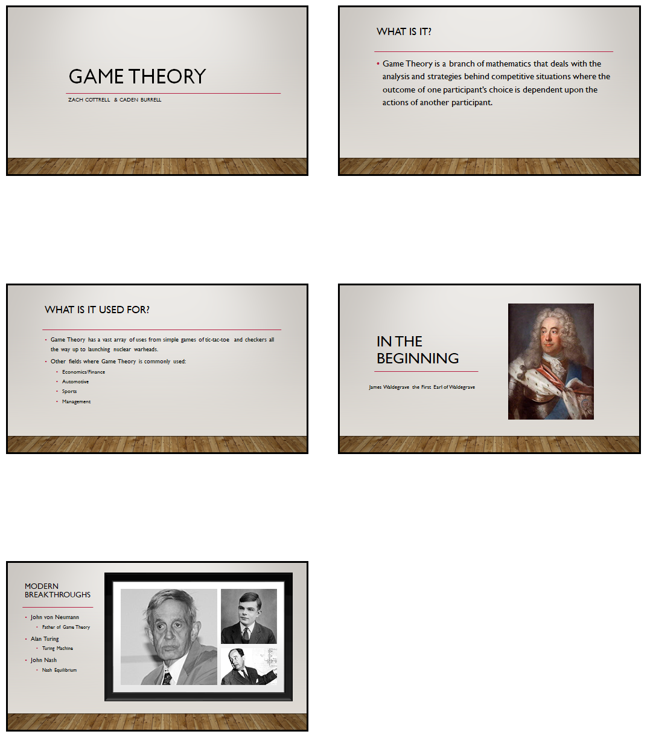

**Included Documents:** The only included document is the one above for background. This is a copy of the slides for the introduction and brief history of game theory.

**References:**

Core Standards for Secondary Mathematics III. (n.d.). Retrieved from <https://www.uen.org/core/core.do?courseNum=5630>

Hykˇsov´, M. (n.d.). *SEVERAL MILESTONES IN THE HISTORY OF GAME THEORY*[Scholarly project]. In *SEVERAL MILESTONES IN THE HISTORY OF GAME THEORY*. Retrieved November 14, 2018, from <http://euler.fd.cvut.cz/~hyksova/hyksova_milestones.pdf>