Task Sheet

The Golden Rectangle

1. Use the applet to learn how to construct the Golden Rectangle.

2. Consider the golden rectangle below. Find the ratio of the rectangles’ length to width. This is known as the Golden Ratio.

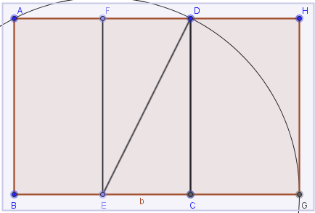

3. See what other ratios you can find in the figure. Is the ratio of the large rectangles length to width the only ratio in the figure that is the Golden ratio? Concentrate on finding the Golden Ratio in the figure as many ways as possible.

4. Consider the rectangle inside the Golden Rectangle that is left over after removing the square, call it R. See what happens when you remove a square from one end of R. What is the ratio of the length to the width of the tiny rectangle left over in R after removing the square? What do you think would happen if you continue this process? Why?